Roll No.: 10 | Name: Amar Singh Dhami | Div: A | Batch: A1

Aim
Data Preprocessing and Exploration: Data Transformation, Outlier analysis, Visualization.

Theory

Data Transformation
Data transformation is the process of converting data from its original format into a format suitable for analysis and data mining. Key techniques include:
- Smoothing: Removing noise from data (e.g., binning, regression).
- Aggregation: Summarizing data (e.g., daily sales aggregated to monthly).
- Generalization: Replacing low-level data with higher-level concepts (e.g., age values categorized into young, middle-aged, senior).
- Normalization: Scaling attribute values to fall within a specified range, such as [0, 1] (Min-Max) or zero-mean with unit variance (Z-score).
- Attribute Construction: Adding new attributes constructed from the existing set to aid mining.

Outliers
An outlier is a data point that deviates significantly from the remaining data, raising suspicion that it was generated by a different mechanism or affected by measurement errors.

Methods of Outlier Detection
- Statistical Approaches: Assume a statistical model (e.g., Gaussian distribution) and flag points that fall outside specific threshold boundaries (Z-score > 3).
- Distance-Based Methods: Identify points that do not have a sufficient number of neighbors within a given distance threshold (e.g., K-Nearest Neighbors).
- Density-Based Methods: Detect outliers based on local density differences compared to neighboring clusters (e.g., Local Outlier Factor or LOF).
- Visual/Graphical Methods: Utilize visual plots such as box plots or scatter plots to manually spot extreme values.

Data Visualization
Data visualization is the graphical representation of information and data using visual

elements like charts, graphs, and maps to identify trends, patterns, and anomalies.

Histogram
A visual representation of the distribution of a continuous variable. Data values are grouped into contiguous intervals (bins), and the height of each bar corresponds to the frequency of data in that bin.

Box Plot
A standardized way of displaying the distribution of data based on a five-number summary:
- Minimum: Lowest data point excluding outliers.
- First Quartile (Q₁): 25th percentile.
- Median (Q₂): 50th percentile.
- Third Quartile (Q₃): 75th percentile.
- Maximum: Highest data point excluding outliers.
- Interquartile Range (IQR): IQR = Q₃ − Q₁ . Points beyond 1.5 times IQR from Q₁ or Q₃ are classified as outliers.

Scatter Plot
A two-dimensional plot using Cartesian coordinates to display values for two continuous variables. It helps assess correlation, strength, and direction of relationships between variables.

Applications of Data Visualization
- Exploratory Data Analysis (EDA): Uncovering hidden patterns, distributions, and initial trends before modeling.
- Anomaly & Fraud Detection: Quickly identifying unusual transactions or outliers in financial or network logs.
- Business Intelligence & Reporting: Communicating insights to stakeholders via intuitive visual dashboards.
- Model Evaluation: Visualizing feature importances, ROC curves, and confusion matrices in machine learning.

Program / Code and Output
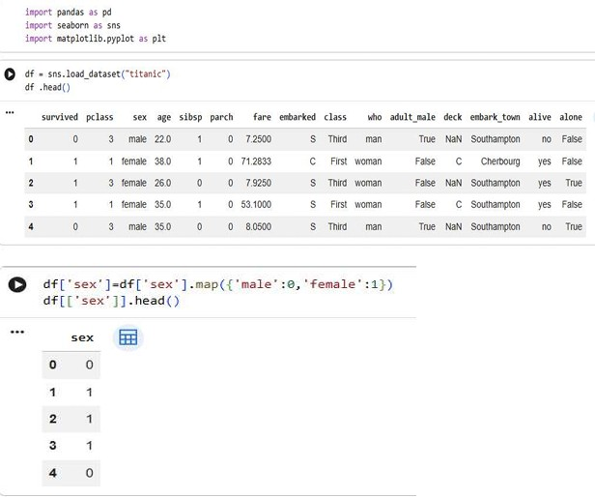

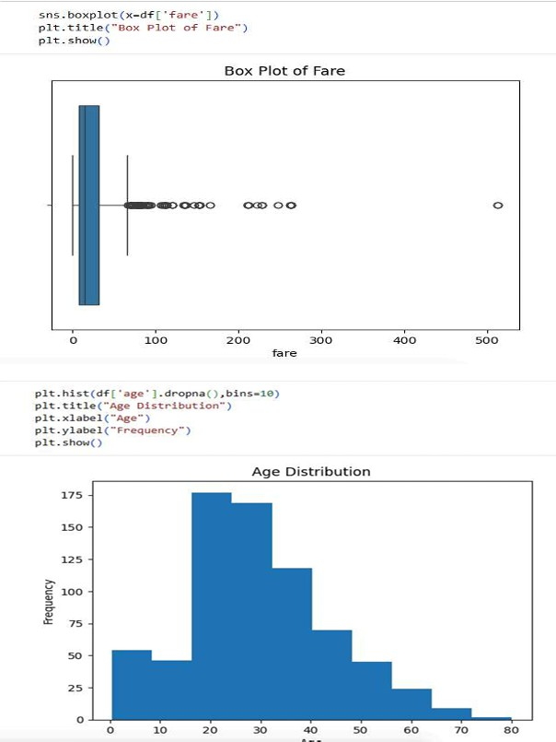

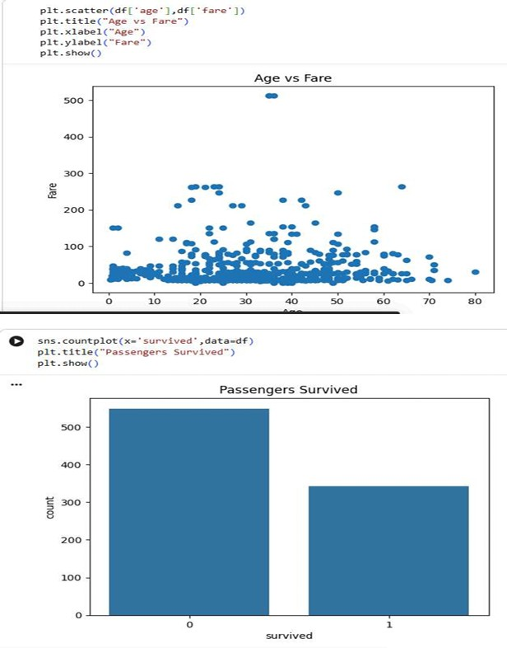

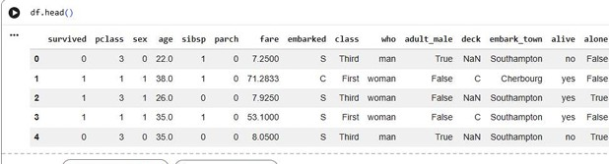

Conclusion
Data transformation effectively prepares raw data into a structured format suitable for mining models. Combining outlier analysis and visual methods—such as histograms, box plots, and scatter plots—provides crucial insights into underlying data distributions, relationships, and anomalous data points prior to advanced analytics.

